Chapattis
Ingredients  100g plain flour  ½ x 5ml spoon salt  1 x 15ml spoon vegetable oil  Notes:  - Don’t forget your apron.  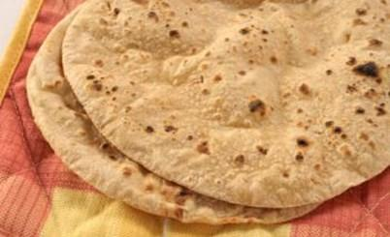 | Method  - Sift the flour and salt into a mixing bowl.  - Make a well and pour in the oil and half the water.  - Mix well and continue adding enough water until you have a firm, soft but not too sticky dough.  - Knead the dough for 3–4 minutes.  - Divide the dough into 4 equal balls.  - Lightly flour a surface and roll each dough ball into a thin circle.  - Fry in a dry pan for 3–4 minutes on each side until lightly coloured  - Remove from the pan and leave to cool.
Chapattis
Ingredients  100g plain flour  ½ x 5ml spoon salt  1 x 15ml spoon vegetable oil  Notes:  - Don’t forget your apron. | Method  - Sift the flour and salt into a mixing bowl.  - Make a well and pour in the oil and half the water.  - Mix well and continue adding enough water until you have a firm, soft but not too sticky dough.  - Knead the dough for 3–4 minutes.  - Divide the dough into 4 equal balls.  - Lightly flour a surface and roll each dough ball into a thin circle.  - Fry in a dry pan for 3–4 minutes on each side until lightly coloured  - Remove from the pan and leave to cool.

